Owner Access to Update Inventory Function

1. **Use Case Flow**

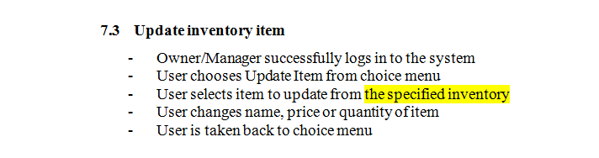

1. **Use Case Diagram**

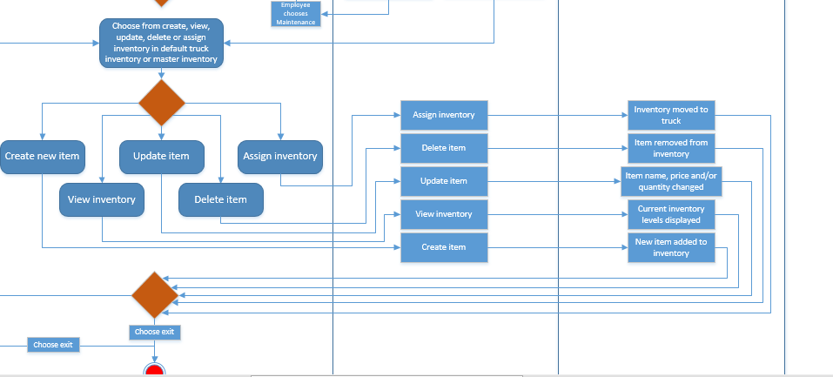

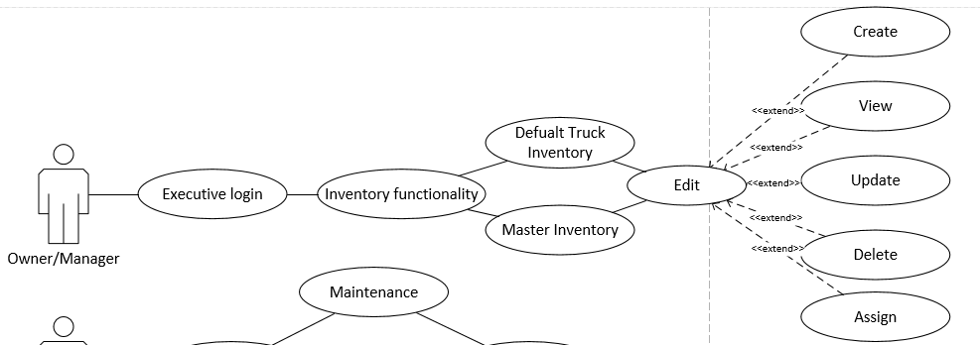

1. **ERD**

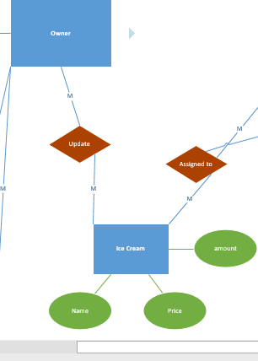

1. **DFD**

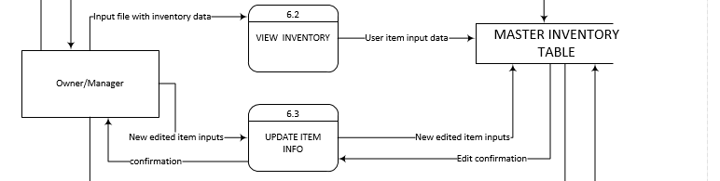

1. **Communication Diagram**

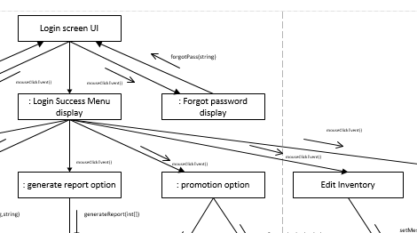

1. **CRC Card**

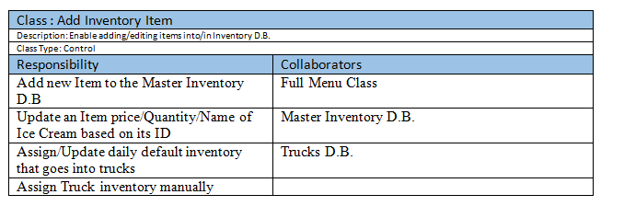

1. **Class Diagram**

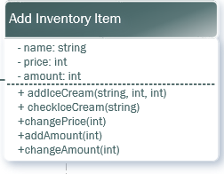

1. **Architecture Diagram**

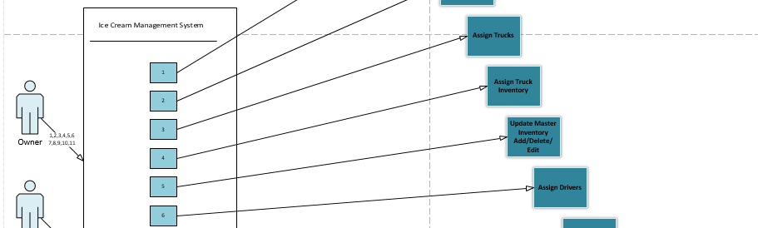

1. **Algorithm**

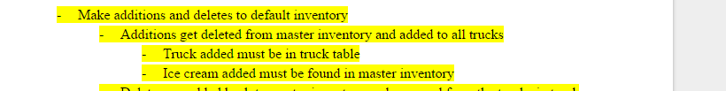

1. **Sequence Diagram**

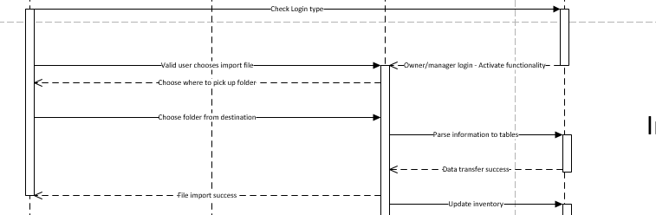

1. **Code**

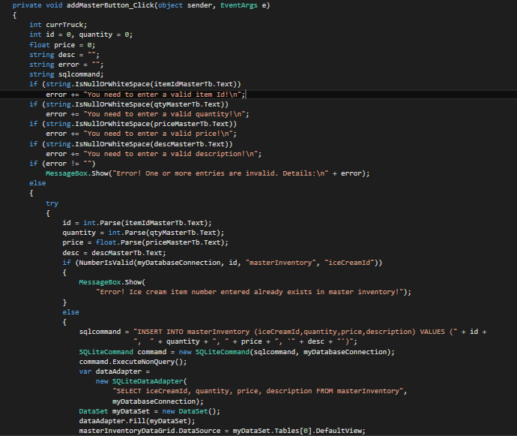

1. **Execution**

